University Of Engineering and Technology, Lahore
Computer Engineering Department

Course Name: Programming Fundamentals | Course Code: CMPE-112L
Assignment Type: Lab Tasks | Dated: 16-03-2026
Semester: 1st | Session: Spring
Lab/Project/Assignment #: 3 | CLOs to be covered: CLO 1
Lab Title: While Loop | Teacher Name: Hafiz Muhammad Mubashar
Lab Evaluation:

CLO1 | Apply appropriate programming techniques to create executable programs to solve well defined problems
 | Level1 | Level2 | Level3 | Level4 | Level5 | Level6
(5)
Total |  |  |  |  |  | /5
Rubrics for Current Lab Evaluation
Scale | Marks | Level | Rubric
Excellent | 5 | L1 | Submitted all lab tasks, BONUS task, have good understanding.
Very Good | 4 | L2 | Submitted the lab tasks but have good understanding
Good | 3 | L3 | Submitted the lab tasks but have weak understanding.
Basic | 2 | L4 | Submitted the lab tasks but have no understanding.
Barely Acceptable | 1 | L5 | Submitted only one lab task.
Not Acceptable | 0 | L6 | Did not attempt
LAB No 3
Lab Goals/Objectives:
To understand and practice while loops in Python. Learn repetition, user input, calculations, and menu-driven programs.
Equipment Required:
Computer or Laptop, Python 3.x, PyCharm or VS Code.
Theory:
A while loop repeats a block of code until the given condition becomes false. It is useful when the number of repetitions is not fixed.
Lab Work:

Task 1: Print numbers from 1 to 10.
Result:
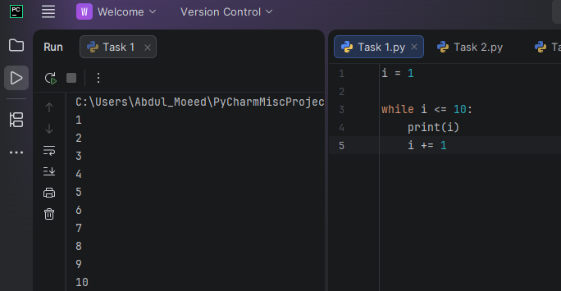

Task 2: Print even numbers from 2 to 20.
Result:
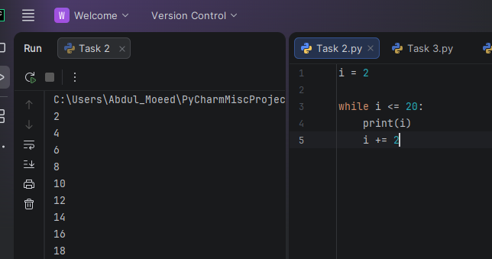

Task 3: Print odd numbers from 1 to 19.
Result:
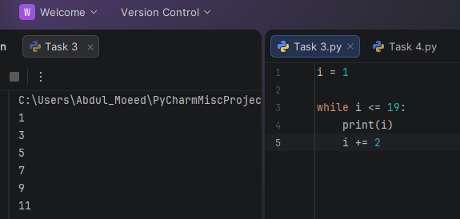

Task 4: Print numbers from 10 to 1.
Result:
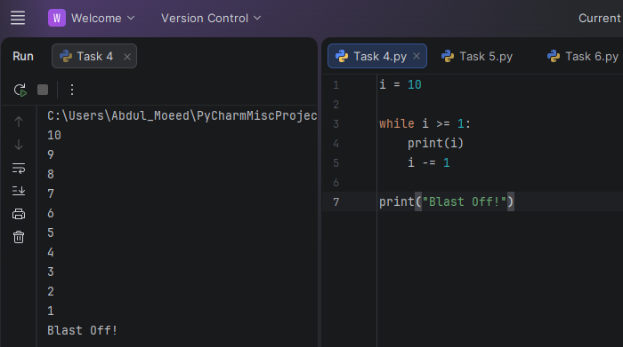

Task 5: Find the sum of numbers from 1 to 10.
Result:
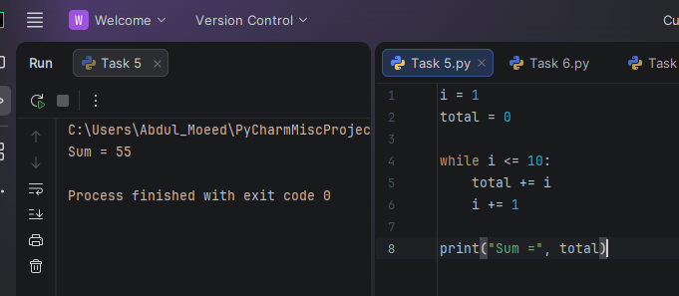

Task 6: Calculate total, average, and grade.
Result: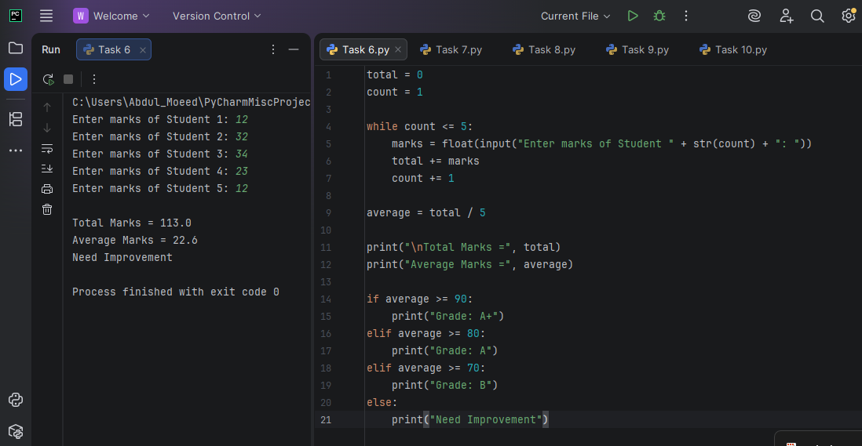

Task 7: ATM withdrawal system.
Result:
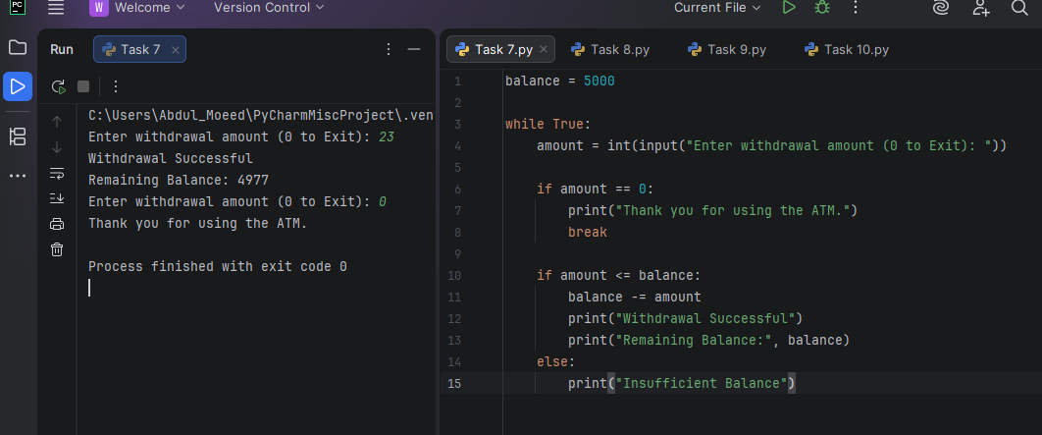

Task 8: Menu-driven calculator.
Result:
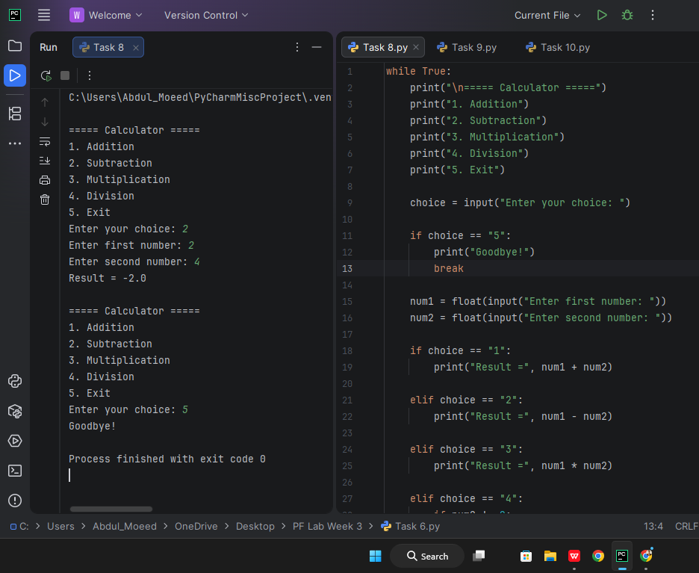
Task 9: Print multiplication tables from 1 to 5.
Result: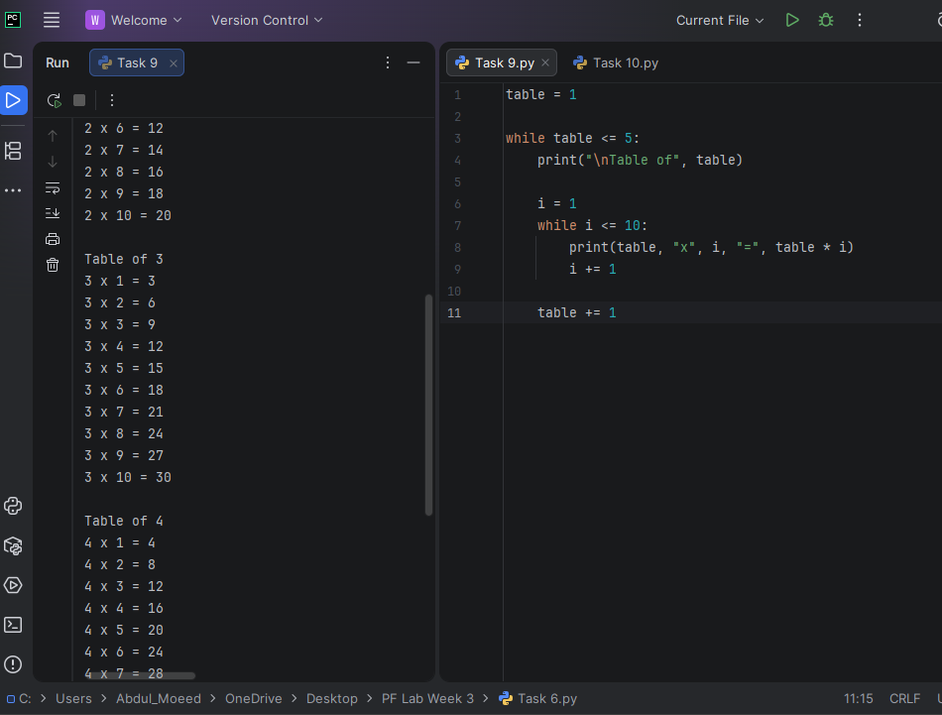

Task 10: Shopping bill with discount.
Result: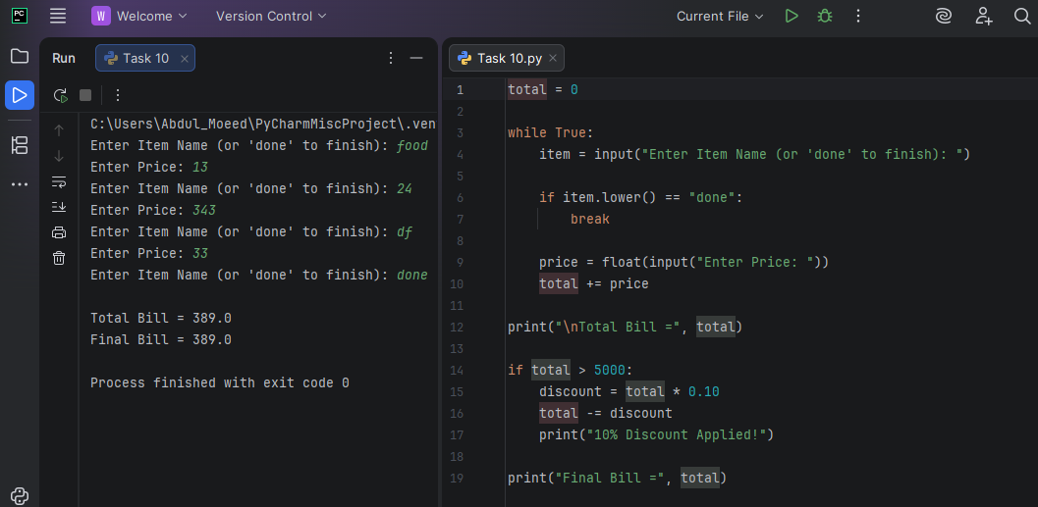

Conclusion:
The lab improved understanding of while loops and their use in different programming problems.

